**EXPERIMENT 3.1**

**NAME: Yash Gupta UID: 20BCS5009**

**SECTION: 709 A Sub: Software Engineering**

**Aim:**

1. Design a Gantt chart for a food delivery application.
2. Design a Gantt chart for a gaming application.

**Requirement Analysis:**

* Software Requirement:

Digram.net

Google Chrome

* Hardware Requirement:

Computer

Internet

1. Design a Gantt chart for a food delivery application.

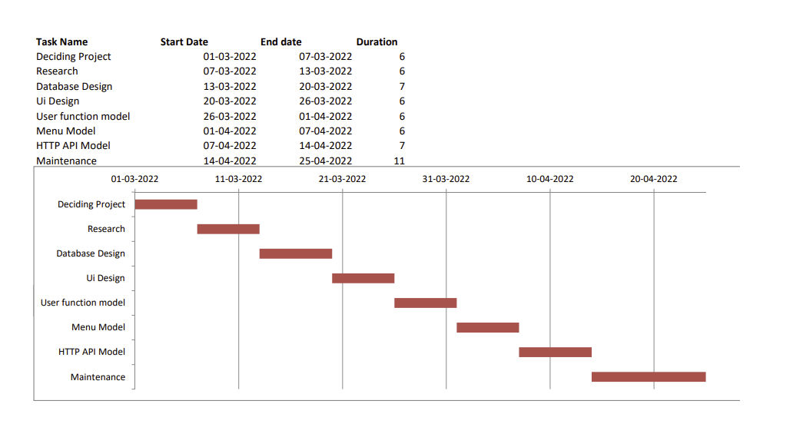

1. **Design a Gantt chat for a food delivery application.**

